Core AI Concepts

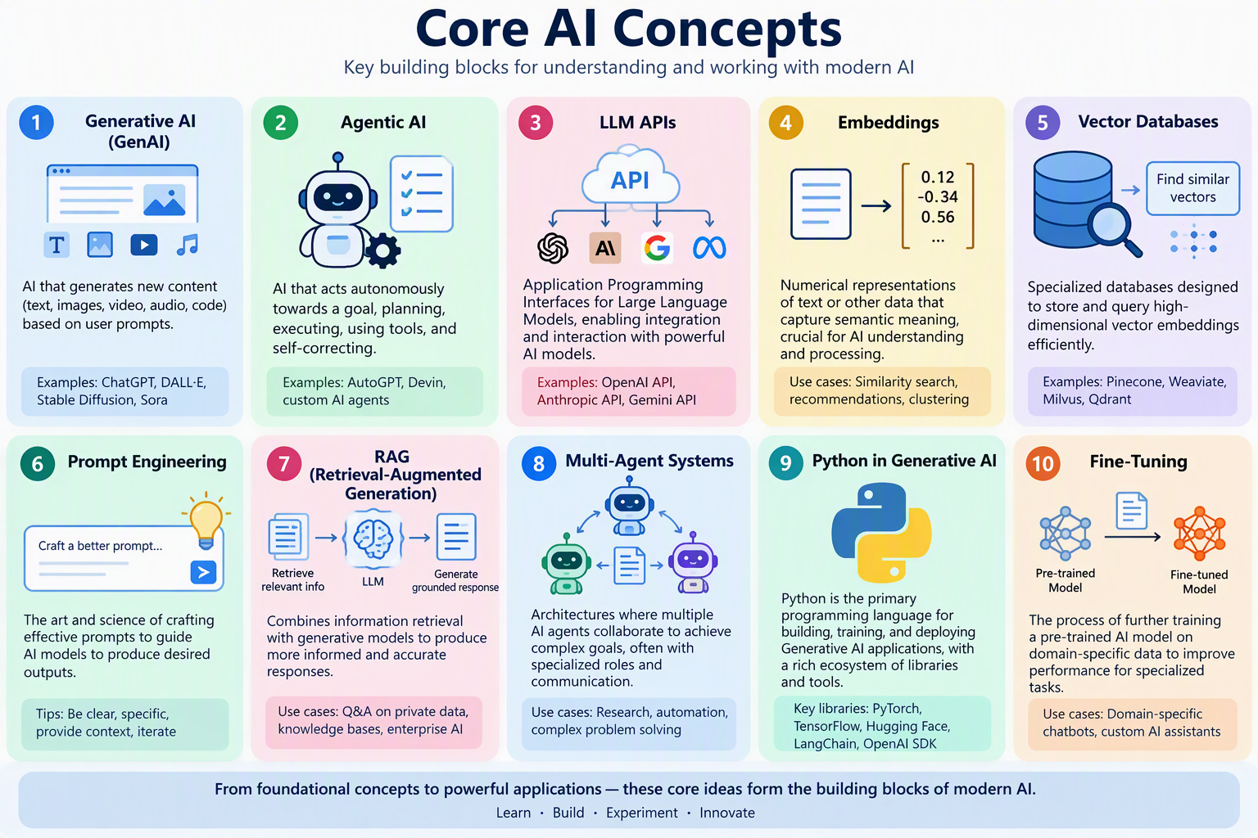
- GenAI: Creates content from prompts.
- Agentic AI: Plans, acts, and achieves goals autonomously.
- LLM APIs: Connect applications to AI models.
- Embeddings: Convert meaning into vectors for AI processing.
- Vector Databases: Store and search embeddings efficiently.
- Prompt Engineering: Design instructions that improve AI outputs.
- RAG: Combines retrieval and generation for grounded responses.
- Multi-Agent Systems: Multiple AI agents working together.
- Fine-Tuning: Adapts models for specialized domains.
- AI Tools & Function Calling: Enables AI to interact with external systems and perform real-world actions.

Python in Generative AI: Python is the primary programming language used to build, train, and deploy Generative AI applications. Its rich ecosystem of AI and machine learning libraries, such as TensorFlow, PyTorch, Hugging Face Transformers, LangChain, and OpenAI SDKs, makes it the preferred choice for developing LLMs, RAG systems, AI agents, and data-processing pipelines.
A good learning sequence would be:
Python ➡️ 📊 Machine Learning ➡️ 🤖 LLM APIs ➡️ 💬 Prompt Engineering ➡️ 🔢 Embeddings ➡️ 🗄️ Vector DBs ➡️ 📚 RAG ➡️ 🧠 AI Agents ➡️ 👥 Multi-Agent Systems

